Price and Output Determination Under Perfect Competition Market Perfect competition is a market structure in which there are large numbers of sellers and buyers competing for homogeneous products at a fixed price determined by the interaction of market/industry demand and supply. Sellers or firms are price takers, and thus, they face a horizontal straight-line demand curve/AR curve that matches the MR curve. So, under a perfect competition market, P=AR=MR, but the cost condition of the firms in an industry may be different. The short-run, as well as long-run equilibrium/price and output determination in the short run as well as the long run of the firm under a perfect competition market is explained below.
Price and Output Determination/Equilibrium of Firm and Industry Under Perfect Competition in the Short-run
Determination of Price Under a perfect competition market, the product's price is fixed and is determined by industry. When the industry reaches a state of equilibrium, the product's price is determined. There are two conditions for the industry equilibrium as market equals market supply and all the firms are in equilibrium.
Determination of Output The duty to determine the level of output is of the firms as they are the price taker. Thus, the firm must satisfy the following two conditions to be in equilibrium or to determine the level of output.
1. Marginal revenue must equal marginal cost, i.e., MR=MC.
2. The slope of the MC curve is greater than the slope of the MR curve. It means the MC curve must intersect the MR curve from below.
Short-Run Equilibrium The short-run refers to the period during which no firms can adjust their fixed factor and supply according to changes in market demand. An industry (a group of firms producing homogeneous products) is said to be in equilibrium in the short run when the market demand is cleared at a given price. It means the industry is in equilibrium or measures its price and output at the point where the quantity demanded and supplied are equal. Similarly, for an industry to be in equilibrium, all the firms operating under it also need to be in equilibrium. The firm in equilibrium does not ensure that it only makes an excess profit. Whether the firm earns maximum profits, normal profits, or losses depends on the firm's efficiency and the average cost level at the short-run equilibrium. There are three possible cases in the short run.

1. If AR=AC, it implies the firm obtains normal profit
2. If AR>AC, it implies the firm obtains excess profit (super normal)
3. If AR<AC, it implies the firm incurs losses.

The following figure shows the measurement of the price and output of the firm and industry in the short run.

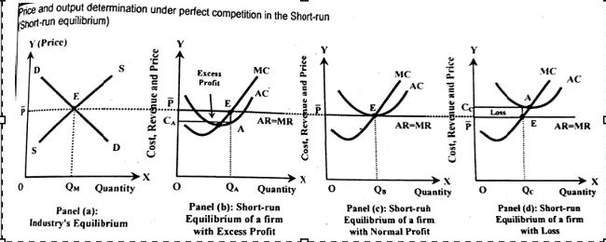

The above figure shows the short-run equilibrium of the industry and firm. In the panel' a’ industry equilibrium is shown where the price P ̅ and output QM are determined at the interaction between market demand and market supply curves. As the firms are price takers, all the firms must sell their product at the price P ̅ determined in the industry.
Panel 'b,' ‘c,' and ‘d' in the above figure show the firms' equilibrium in the short run. At equilibrium, a perfectly competitive firm may earn an excess profit (P>AC) or normal profit (P=AC) or suffer loss (AVC<P<AC) in the short run based on the short-run average cost. These conditions are briefly explained below.

Excess Profit/Supernormal profit/Abnormal Profit (AR/P>AC)
Figure ‘b’ in the above figure shows the case of excess profit. At equilibrium, the firm is producing OQA units of output at per unit cost OCA and selling at the price P ̅. In this case, the firm earns excess profit in the short run as the equilibrium price P ̅ is higher than the average cost. That is, the price is greater than the average cost. The excess profit of the firm is represented by the area AEP ̅CA. In the figure, the total revenue is OQAEP ̅, the total cost is OCAAQA and the total profit is OQAEP ̅- OCAAQA=AEP ̅CA.
Normal Profit (AR=AC)
In the panel ‘c’ of the above figure, the equilibrium point shows that the firm is producing OQB units of output at per unit cost QBE and selling at the price P ̅ and the firm is earning just the normal profit as equilibrium price P ̅ is equal to the average cost QBE that is P=AC. Normal profit is the profit that is just sufficient to run the business. Here in the figure, total revenue is OQBEP ̅, the total cost is OQBEP ̅ and total profit is OQBEP ̅- OQBEP ̅=0.

Loss (AR<AC)
In the panel ‘d’ of the above figure, the equilibrium point shows that the firm is producing OQC units of output at per unit cost OCC and selling at the price P ̅ and the firm is bearing loss as equilibrium price P ̅ is less than the average cost OCC that is P<AC. Here in the figure, total revenue is OQCEP ̅, the total cost is OQCACC and the total profit is OQCEP ̅- OQCACC=-EACCP ̅.

The firm in the short run will continue to produce if the revenues cover the variable cost that is until the price is greater than the average variable cost and losses equal total fixed costs, whether the firm produces or not. Thus, the lowest point on the AVC curve, at which MC=AVC is known as called shutdown point of the firm.

Long-Run Equilibrium
Under a perfect competition market, firms can freely enter and exit out of the industry in the long run only. In the long run existing firms have also able to adjust their capacity according to the demand of the market. Therefore, the firm and industry reach their respective long-run equilibrium through a continuous process of adjustment and readjustment of price and output with a change in market conditions. If after adjustments, the firms are still unable to cover their total costs or the firms incurring losses (P<AC), will exit the industry. If the existing firms are earning an excess profit (P>AC), then new firms will enter the industry. The exit of firms from the industry will shift the supply curve to the left and push the price up until P=minimum AVC, and entering new firms will shift the supply curve of the firm to the right and push the price down until P=minimum point of LAC. Here P= minimum point of LAC ensures normal profit.
A firm must fulfil the following conditions to attain equilibrium in the long run.
1. Price (P) or AR or MR= LAC=LMC=SAC
2. LMC curve must intersect MR curve from below
Therefore, in the case of a perfect competition market, whatever may be the profit loss situation in the short-run equilibrium, the firm earns just normal profit in the long-run equilibrium. This can be shown in the following diagram.

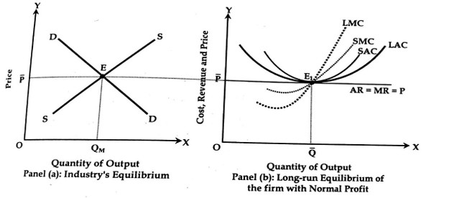
The above figure shows the long-run equilibrium of firms and industry with the help of short run equilibrium. Demand and supply intersect at point E in panel 'a’ of the above figure that determines equilibrium quantity QOM and price P ̅. In figure ‘b’ when the price is P ̅ the firm is in equilibrium at point E1 where AC is equal to MR. It means at that point P ̅=LAC=LMC=SAC=SMC and LMC curve is intersecting MR curve from below. Similarly, the LAC curve is tangent to the AR curve that is P= minimum LAC. Therefore, at equilibrium, the firm is producing OQ ̅ units of output at a per-unit cost Q ̅E1 and selling at a price P ̅. Here equilibrium price P ̅ is equal to the average cost Q ̅E1 i.e. P=LAC. Therefore, the firm is earning normal profit in the long run.
At the minimum point of LAC, the following equilibrium condition is fulfilled SMC=LMC=LAC=SAC=P=AR=MR

A perfect competition market is regarded as an efficient market as it ensures minimum production cost. The existing plants are also used at their full capacity or there is full utilization of the plants in the long run. So, under this market, the output is produced at the minimum point of the LAC curve, so it is considered as the socially desirable market.

